EXPT NO: 3 | IMPLEMENTATION OF CONVOLUTIONAL NEURAL NETWORKS (CNNs) FOR IMAGE CLASSIFICATION
DATE: 10/08/2026

PRE-LAB QUESTIONS (PROVIDE BRIEF ANSWERS TO THE FOLLOWING QUESTIONS)
- What is a Convolutional Neural Network (CNN)?

A Convolutional Neural Network (CNN) is a type of deep learning neural network mainly used for image processing and image classification. It automatically learns important features such as edges, shapes, and textures from images using convolutional layers.

- What are the functions of convolution and pooling layers in a CNN?

Convolution layer: Extracts important features from an image using filters (kernels), such as edges, textures, and patterns.
Pooling layer: Reduces the spatial size of feature maps while retaining important features. It helps reduce computation and overfitting.

- Differentiate between image classification and object detection.

Image Classification | Object Detection
Identifies what is present in an image. | Identifies objects and their locations.
Produces a class label. | Produces class labels and bounding boxes.
Example: "Cat" | Example: "Cat at this location."
- Classification tells what the image contains, while detection tells what it contains and where it is.

- Why is image preprocessing important before training a CNN model?

Image preprocessing makes images suitable for training and improves model performance. Common preprocessing steps include resizing images to the same size, normalizing pixel values, and converting images into the required format. It can also help the model train faster and more effectively.

- What are the advantages of using benchmark datasets such as CIFAR-10 or Kaggle image datasets.

Benchmark datasets provide standardized and real-world image data for training and evaluating CNN models. They allow students and researchers to compare different models, test performance, and practice image classification without having to collect a dataset from scratch.

AIM
To design, implement, and evaluate a Convolutional Neural Network (CNN) for image classification using a benchmark image dataset.

SOFTWARE REQUIREMENTS
- Python
- TensorFlow/Keras or PyTorch
- Google Colab
- Matplotlib
- Kaggle Dataset (e.g., CIFAR-10, Cats vs Dogs, Intel Image Classification)

OBJECTIVES
Students will be able to:
- Understand the architecture of Convolutional Neural Networks.
- Implement a CNN model for image classification.
- Train and evaluate a CNN using a real-world image dataset.
- Visualize training and validation performance.
- Analyze the effectiveness of CNNs for image recognition tasks.

PROCEDURE
PART A: DATASET PREPARATION
- Perform the following tasks:
- Download an image dataset from Kaggle or use CIFAR-10.
- Load the dataset.
- Preprocess images by resizing and normalization.
- Split the dataset into training, validation, and testing sets.

TASK: A
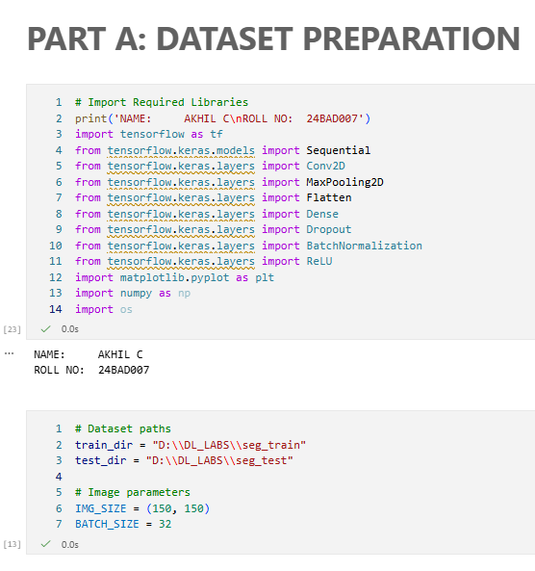
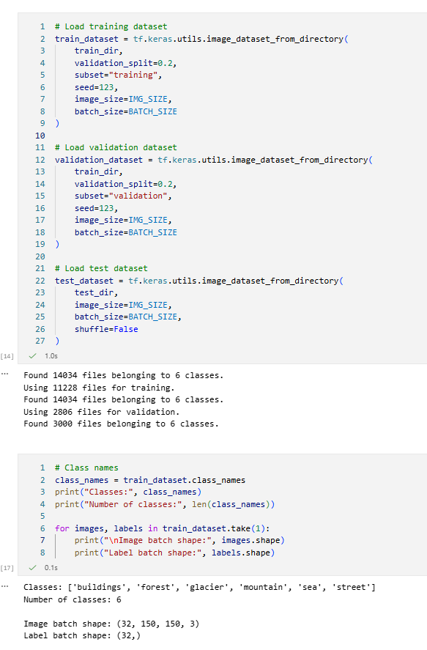
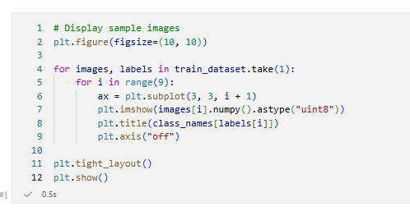
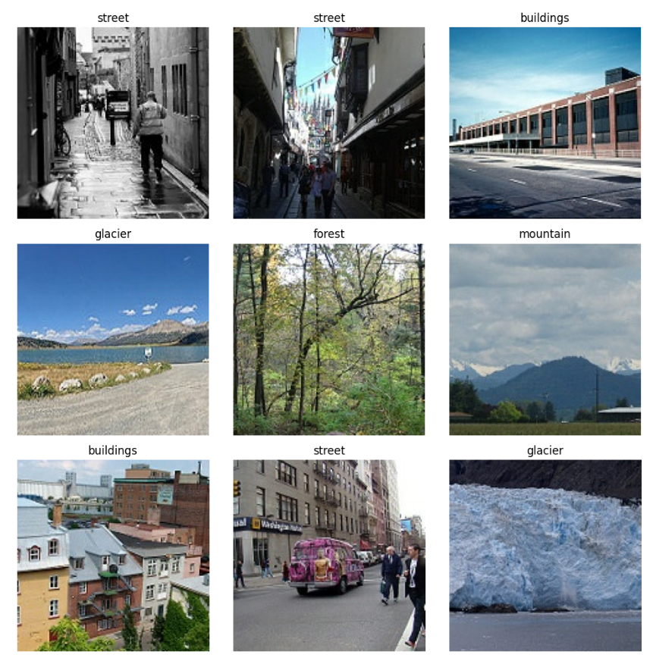
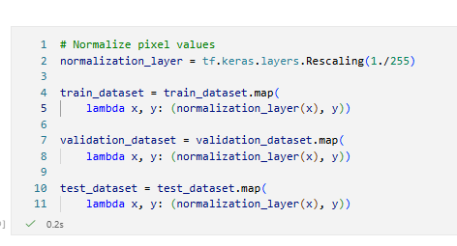

PART B: CNN MODEL IMPLEMENTATION
Build a CNN model consisting of:
- Convolution layers
- ReLU activation
- Max Pooling layers
- Fully Connected layers
- Softmax output layer

Compile the model using:
- Appropriate optimizer
- Cross-entropy loss function

TASK: B
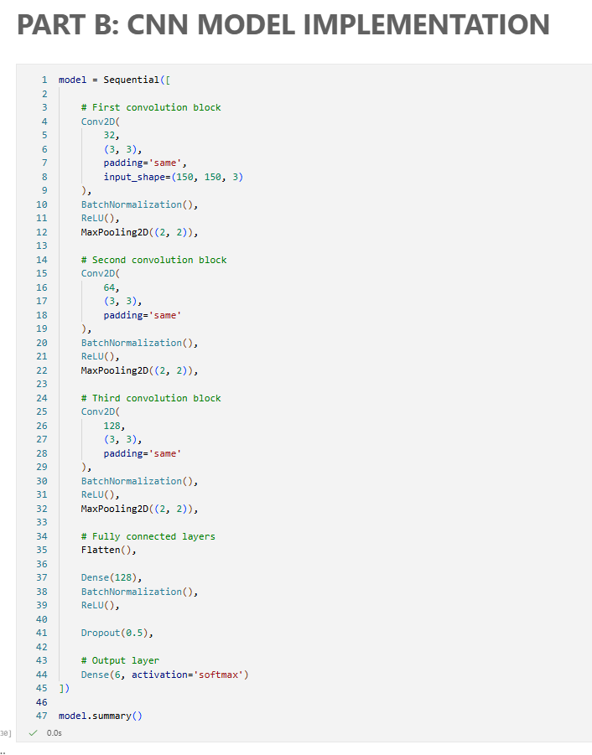
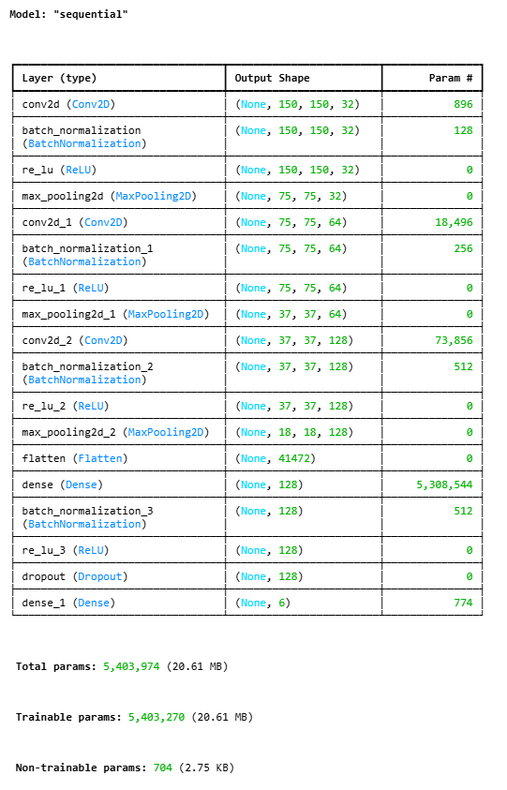
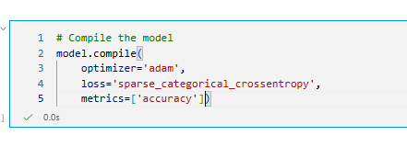

PART C: MODEL TRAINING AND EVALUATION
Train the CNN model.
Record:
- Training accuracy
- Validation accuracy
- Training loss
- Validation loss
- Testing accuracy
Plot:
- Accuracy vs Epoch
- Loss vs Epoch

TASK: C
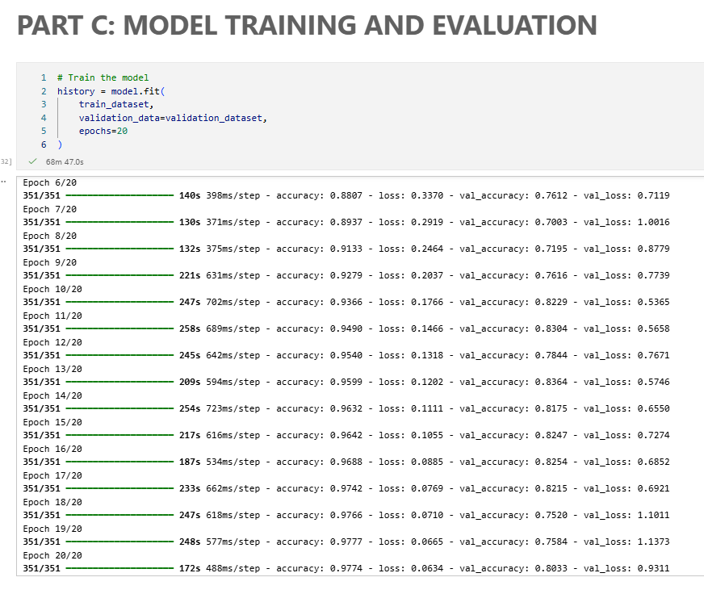
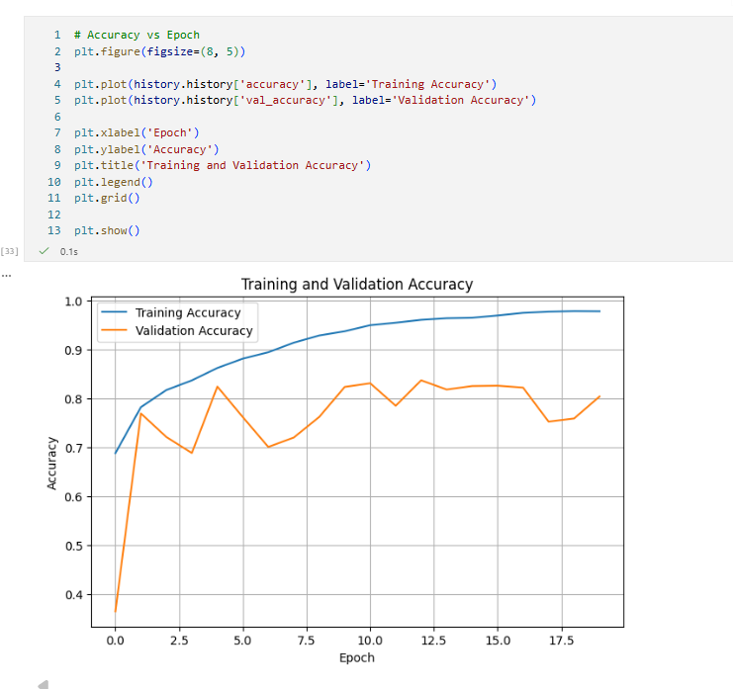
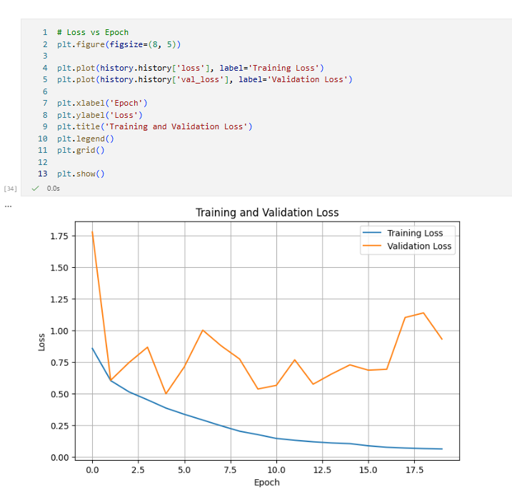

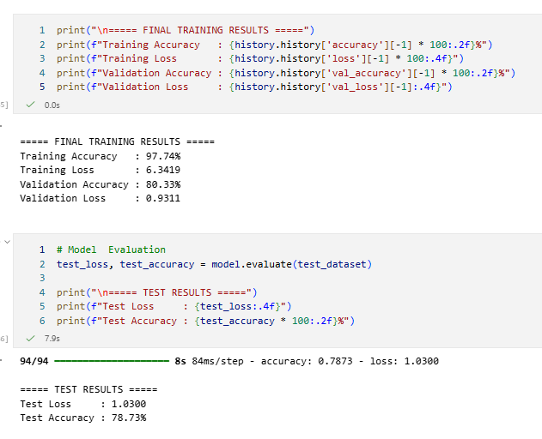
PART D: PERFORMANCE ANALYSIS
Analyze:
- Classification accuracy
- Confusion Matrix
- Sample predictions
- Misclassified images
Discuss the strengths and limitations of CNNs for image classification.

TASK: D
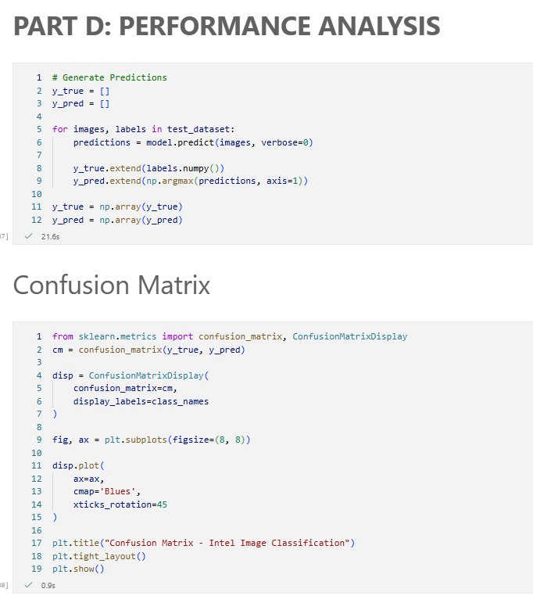
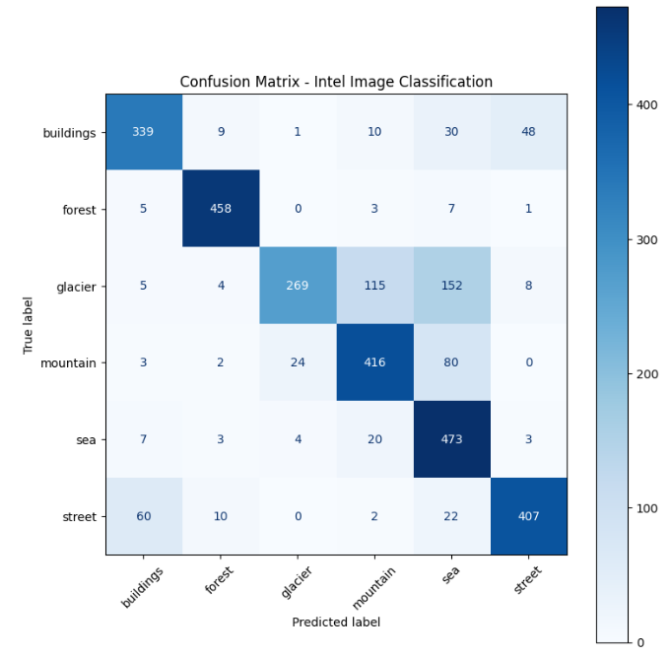
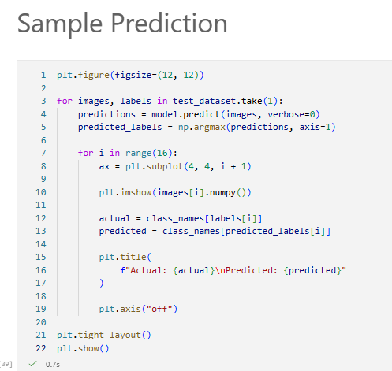
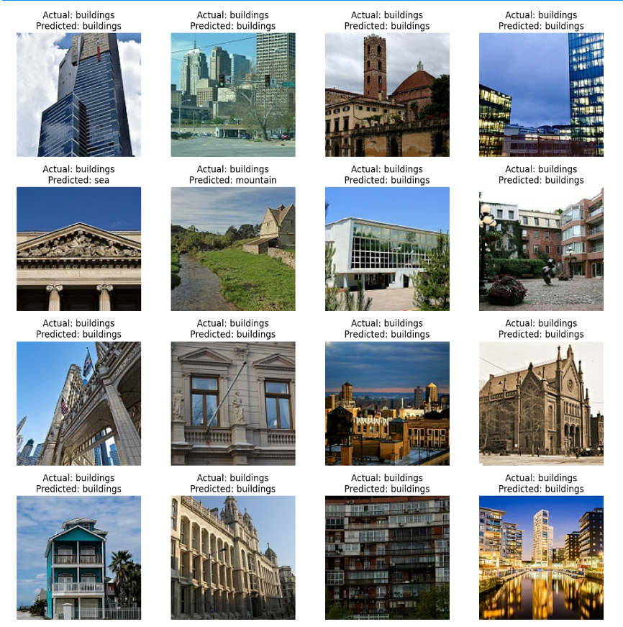
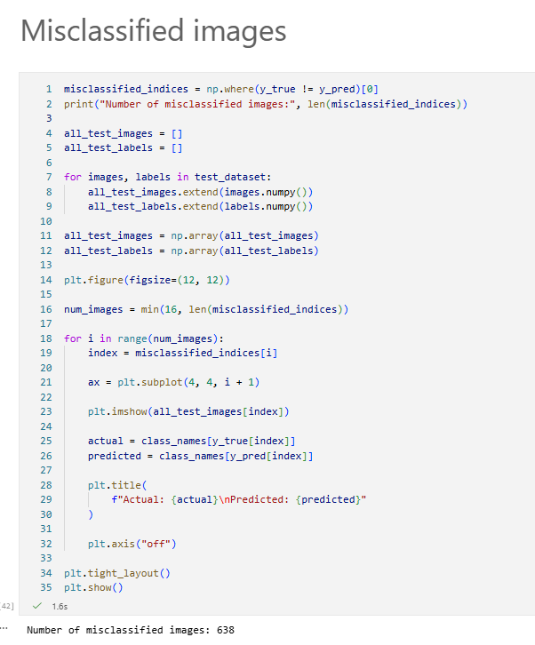
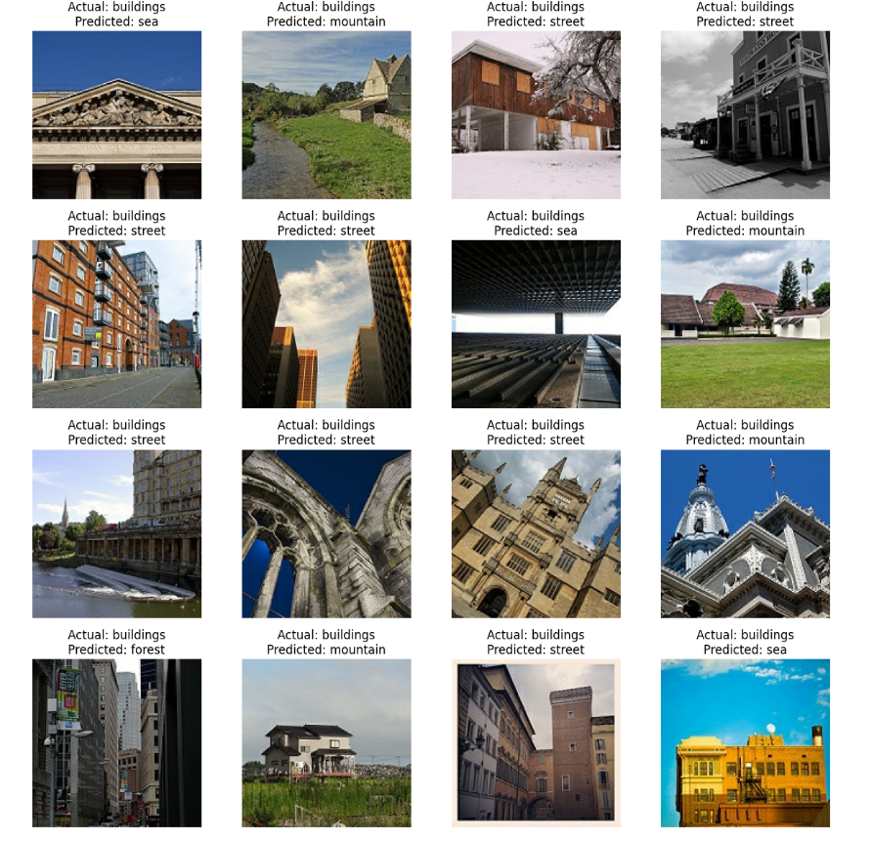
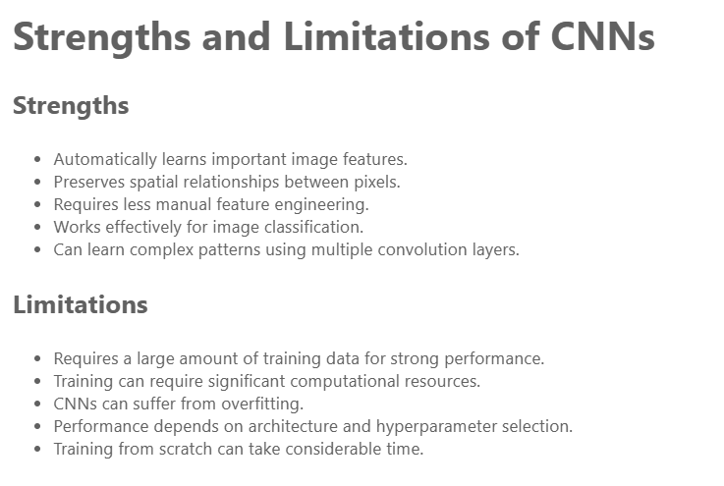
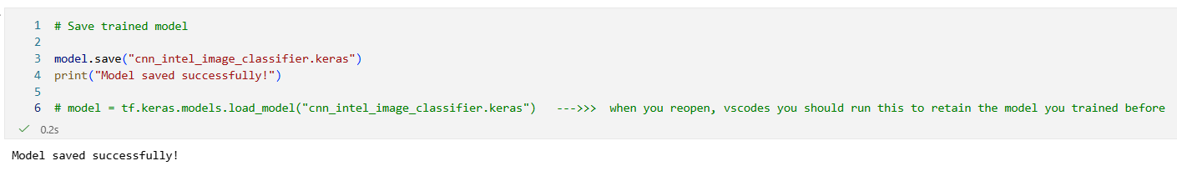

(CODE: CONATAINS STUDENT ROLL NOS
SCREENSHOT OF CODE
SCREENSHOT OF OUTPUT)

EXPECTED OUTCOME
Students will gain practical experience in designing, training, and evaluating CNN models for image classification and understand how CNN architecture influences classification performance.

POST-LAB QUESTIONS (PROVIDE BRIEF ANSWERS TO THE FOLLOWING QUESTIONS)
- Why are convolution layers more effective than fully connected layers for image processing?

Convolution layers are more effective because they preserve the spatial structure of images and automatically learn local features such as edges, textures, and shapes. They also use shared weights, which significantly reduces the number of parameters compared with fully connected layers.

- How does Max Pooling improve CNN performance?

Max Pooling reduces the spatial dimensions of feature maps while retaining the most important features. This reduces computational cost, helps control overfitting, and makes the model more tolerant to small changes in object position.

- Which hyperparameters significantly affected your CNN model performance?

The number of filters, learning rate, batch size, number of epochs, and dropout rate significantly affected the CNN performance.
Increasing the number of filters helped the model learn more complex image features, while the learning rate and number of epochs influenced how effectively the model learned.
The dropout rate also helped reduce overfitting.

- What challenges did you encounter while training the CNN model?

During training, challenges included long training time,handling a large number of images, and maintaining a good balance between training and validation accuracy.
There was also overfitting happened when the training accuracy increased faster than the validation accuracy.
Choosing suitable hyperparameters and preprocessing the images properly can help overcome these challenges.

- Suggest two improvements that can increase the classification accuracy of your CNN.

Two possible improvements are:

Data augmentation: Applying random rotation, flipping, zooming, and shifting can provide more diverse training samples and improve generalization.

Transfer learning: Using a pretrained model such as MobileNet, ResNet, or EfficientNet can provide better feature extraction and potentially achieve higher accuracy than a CNN trained from scratch.

ASSESSMENT
Description | Max Marks | Marks Awarded
Pre Lab Exercise | 5
In Lab Exercise | 10
Post Lab Exercise | 5
Viva | 10
Total | 30
Faculty Signature

